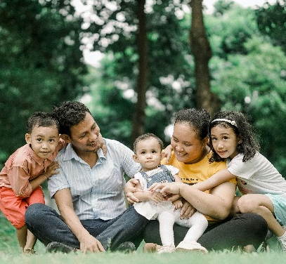
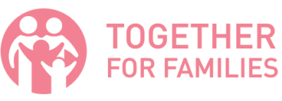
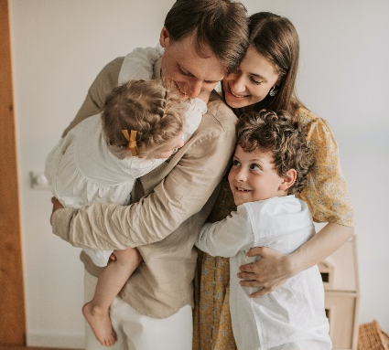

WISHLIST

Thank you for considering making a tax-deductible donation to help keep families together.

MOST NEEDED ITEMS

- Baby Supplies: Gently used pack ‘n plays, new infant car seats, new & packaged pacifiers, ointments, baby lotion, powder, shampoo, bottles, & sippy cups

- Children & Youth Hygiene Items: shampoo, conditioner, body wash, & lotion

- Family Cleaning Supplies: laundry detergent, dish soap, & disinfectant cleaner

- Infant & Children’s Clothing: new & packaged underwear & socks

- Gift Cards: gas cards, uber/lyft

Please drop off your donations at our Resource Center
1301 Shiloh Road NW, Unit #850 Kennesaw, GA 30144
sarah@advochild.org

Monday: 10am-2pm
Wednesday: 10am-5pm
First Saturday of the Month: 10am-2pm

Want to purchase items off our Amazon Wish List?

Scan the QR code below!
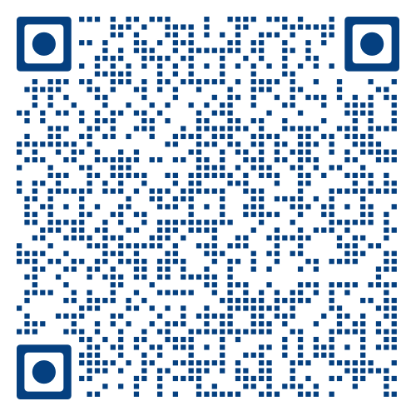
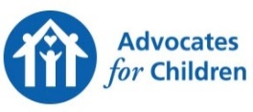
Detailed List of All Items Needed

Items in BLUE INK and BOLDED can only be accepted NEW.
Used items must be clean, gently used, and in perfect working condition.
For all larger used items such as twin and toddler bed frames, please email
sarah@advochild.org a description and photo of the items before bringing them to the resource center, so we can ensure that we have the space and need for the items at the time. We are unable to accept used mattresses.
Thank you for considering making a tax-deductible
donation to support vulnerable children and their families!

Household Essentials
For Personal Hygiene:
- maxi pads and tampons
- women’s and men’s socks
- toothpaste
- toothbrushes
- shampoo
- conditioner
- deodorant
- soap

For Home:
- trash bags (13 gallon or larger)
- multi-purpose cleaner
- paper towels
- dish soap & dishwasher detergent
- sanitizing wipes
- zipper storage bags (quart and gallon size)
- laundry detergent
- bath towels & wash clothes

For Organization:
- planners

Gift Cards:
- gas cards
- Wal-Mart
- Target
- Kroger
- Uber/Lyft
- Ingles

For Home Safety:
- first aid kit

Baby Essentials
Baby Clothing Essentials (gently used & in season)
- onesies
- shirts
- pants
- one-piece pajamas
- rompers or other dress-up outfits
- socks or booties
- blankets

Baby Nursery Essentials
- bassinets
- pack ‘n plays
- crib/toddler mattresses
- fitted crib sheets
- fitted pack ‘n play sheets
- waterproof crib mattress covers
- baby monitors

Baby Diapering Essentials
- diapers (all sizes)
- baby wipes (preferably fragrance free or sensitive skin)
- diaper rash creams
- waterproof changing pad covers
- diaper bags
- potty chairs

Baby Bath Essentials
- baby bathtubs
- washcloths
- hooded baby towels
- baby shampoo and body wash
- baby lotion
- baby powder
- soft hairbrushes

Baby Health Essentials
- baby nail clippers or files
- baby thermometer (rectal or digital)
- petroleum jelly and sterile gauze (for circumcision care)
- nasal aspirators
- saline drops
- cotton balls
- pacifiers
- safety essentials (plug protectors)
- baby safety gates

Baby Feeding Essentials
- nursing pads
- nipple creams
- burp cloths
- bibs
- baby feeding pillows
- breast pumps
- nursing bras
- bottles
- sippy cups
- formula

Baby Gear Essentials
- infant car seats & convertible car seats
- strollers
- baby bouncers & walkers
- infant carriers
- booster chairs
- baby play mats

Toddler & Children Essentials

Children’s Clothing Essentials
Please bring new or very gently used clothing with no stains or tears and in season. Thank You!
- shirts
- pants
- shorts
- pajamas
- coats & jackets
- mittens or gloves
- hats
- shoes
- underwear
- socks

Children’s Bedding Essentials
- twin mattresses
- twin & toddler size pillows
- twin size waterproof mattress covers, sheets, blankets, & comforters
- twin size bed frames for use without box springs (all parts and hardware)
- twin over twin bunk beds (all parts and hardware)
- toddler bed frames
- toddler mattresses
- toddler waterproof mattress covers, sheets, & blankets
- air mattresses with built-in pumps

